

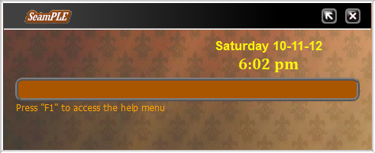

  Liu Weiyuan  Programmer, Designer, Content Producer |   Riandy  Content Producer, Programmer, Time-Keeper |   Cham Wen Bin  Leader, Designer, Programmer |   Pan Wenren  Programmer, Designer, Content Producer |   John Francisco  Programmer, Designer, Content Producer
User and Programmer Manual
V 0.5

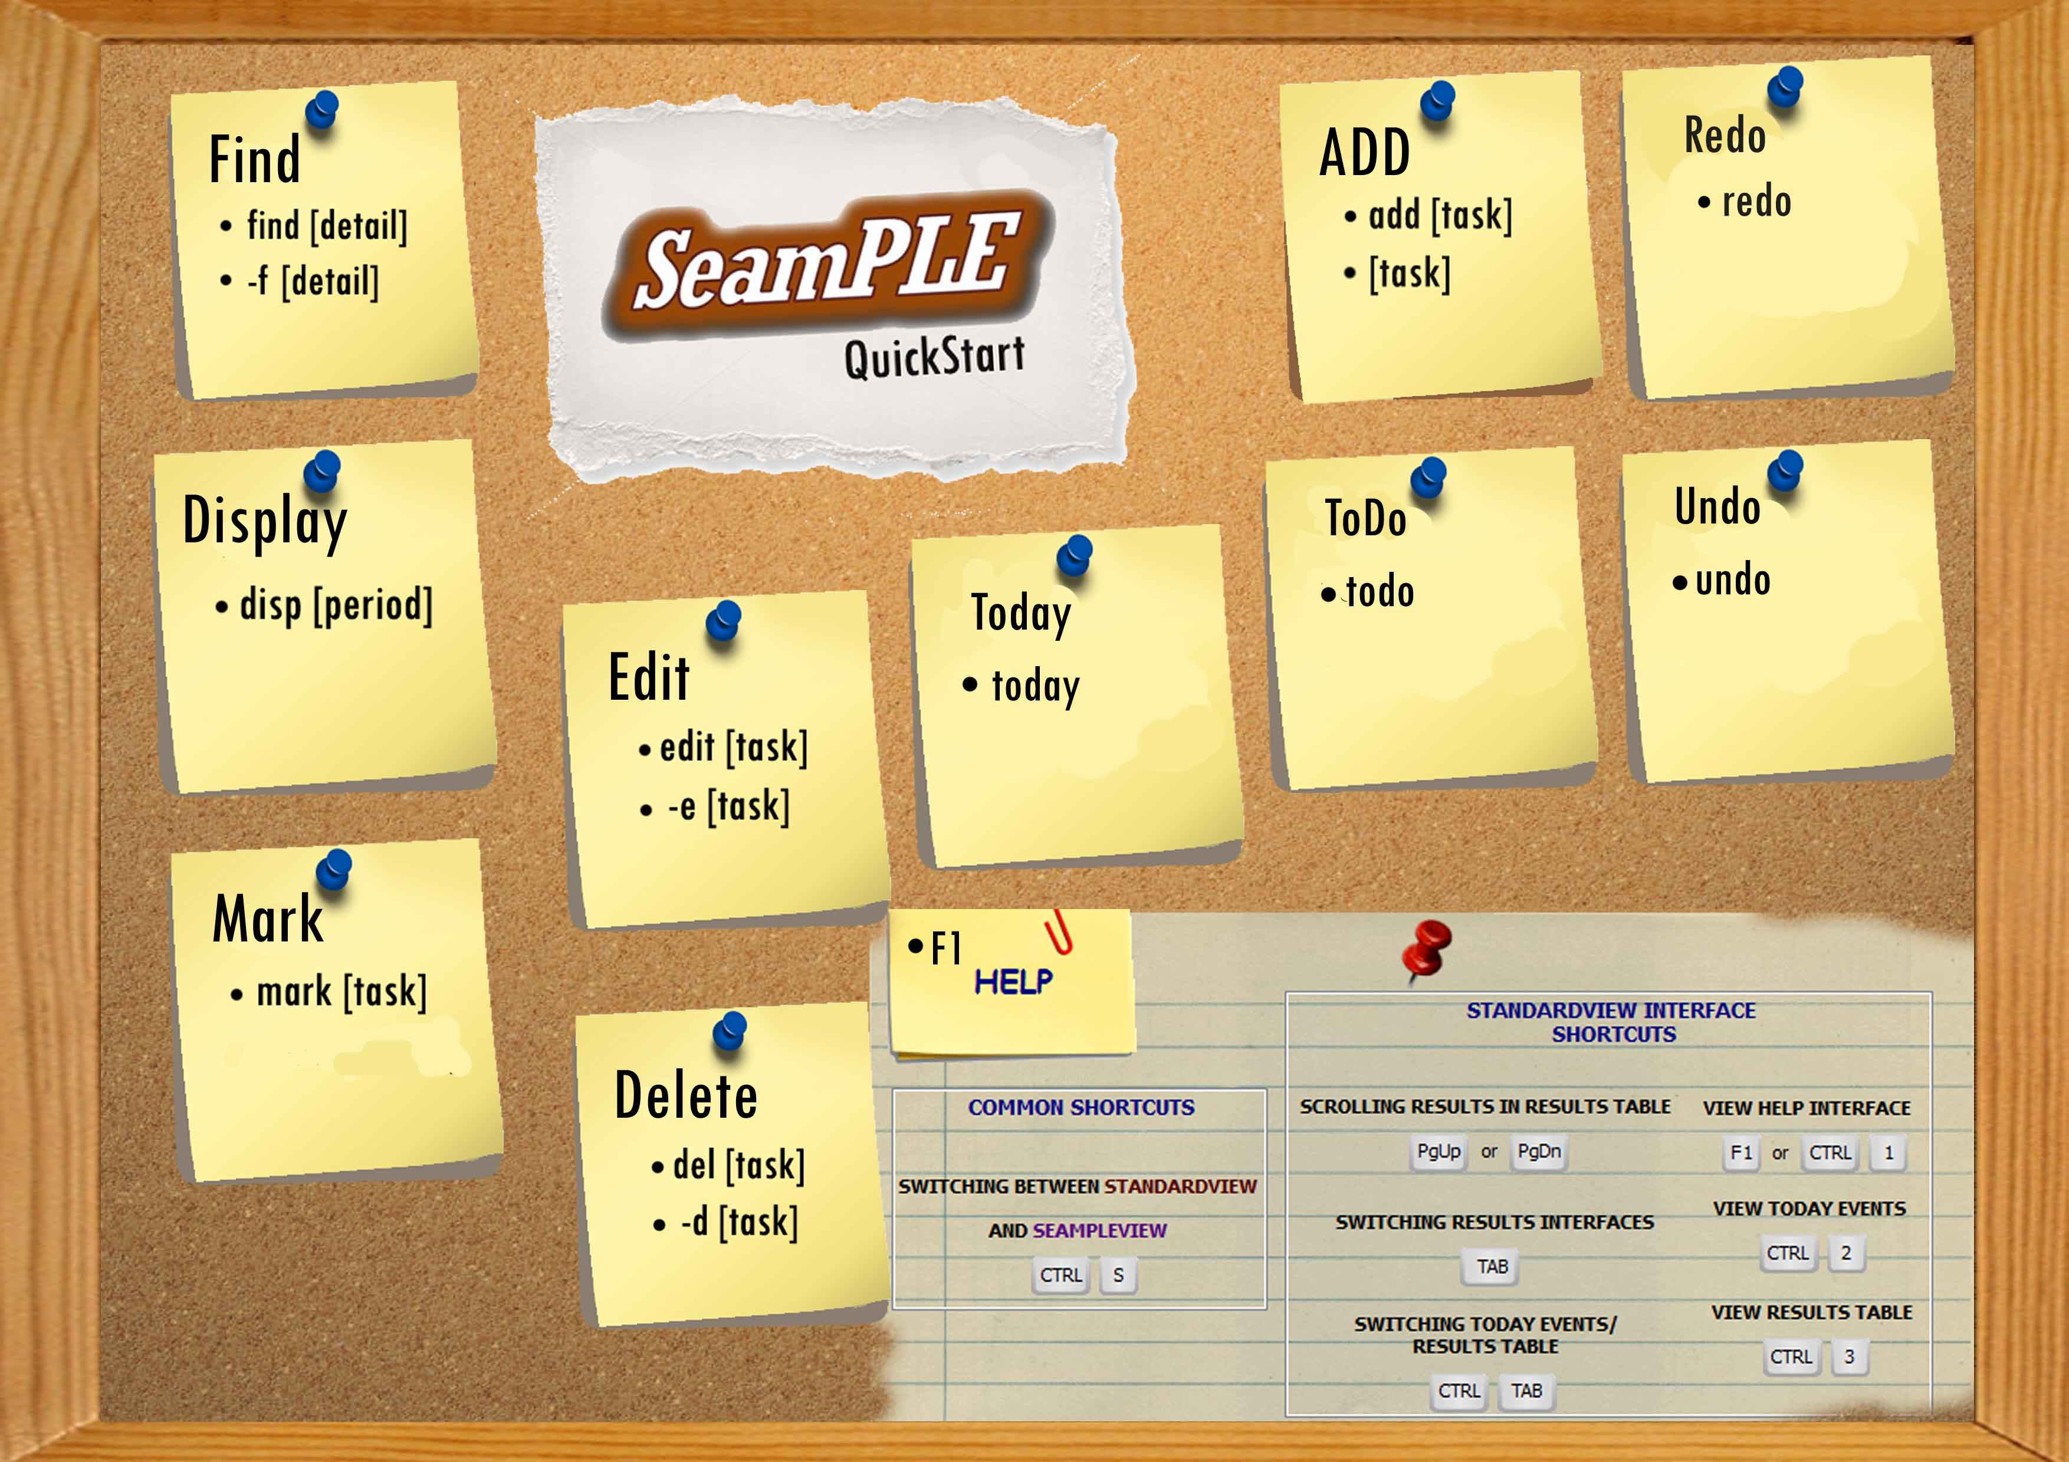
What is SeamPLE Software?
SeamPLE is a todo list widget that is aimed at allowing users (you!) to have total control over day-to-day events. We help you achieve this through our simplistic yet intuitive user interface, as well as our intelligible widget command list.

Getting SeamPLE to run
Operating System Requirement: WindowsXP/WindowsVista/Windows7[RECOMMENDED]
To run the program, double click SeamPLE.exe icon. (Simple, ain’t it?)

Experiencing SeamPLE
There are two views to our SeamPLE application: SeamPLE view and Standard view

SeamPLE view Standard view
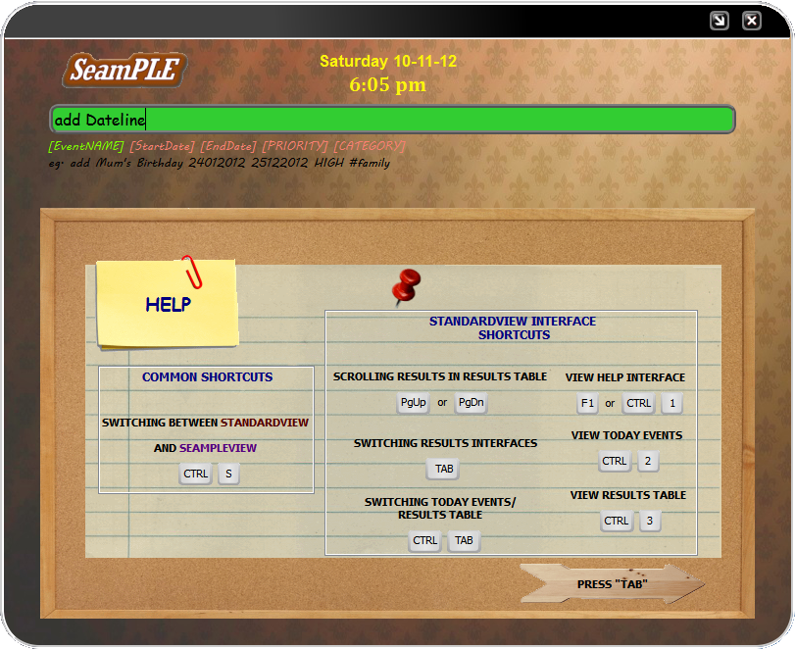

SeamPLE view is seen most regularly as a toolbar notification while Standard view is seen only when the program is maximised.
Using the Standard view offers the user more customization options, such as having the ability to check through the day's events and tasks or even searching for an event that is keyed into SeamPle previously. The SeamPLE view offers the user an alternate and more convenient way of using the program, by allowing the user to issue commands quickly without the need for maximizing the widget view.
To view the different commands that can be used with SeamPLE, please flip to the next page.

Command Walkthrough

ADD
Description: Use this command to add a specific task that you want.
Just type the detail that you want and SeamPLE will help you to manage them!
Command : add [task] [date] [category] [time] [priority] 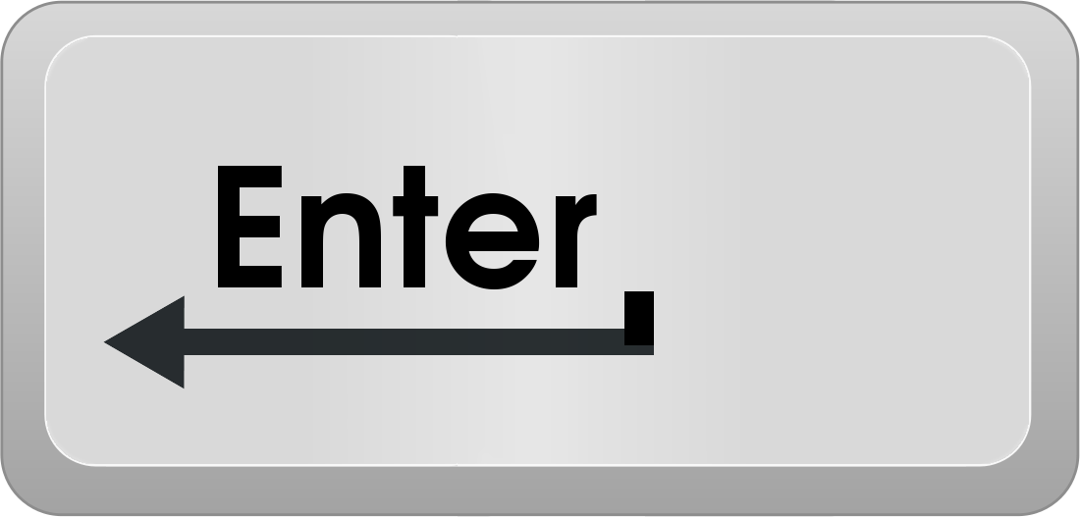
: [task] [date] [category] [time] [priority]
Ex: add dinner With mary → Add task into today’s list of things to do.
Meet investors Monday → Add task into the upcoming Moday.

Edit
Description: Use this command to edit any details of a specific task.
Just type the details that you want to edit and SeamPLE will update accordingly!
Navigate across fields that you wish to edit with the tab button.
Command : edit [task] [date] [category] [time] [priority]
: -e [task] [date] [category] [time] [priority]
Ex: Edit meeting HIGH → Edit task’s Priority to be high .
-e homework Monday → Edit task’s Date into the upcoming Moday.

Delete
Description: Use this command to delete any specific task.
Just type the task with the ID that you want to delete and SeamPLE will clear them!
Command : del [task ID] [eventName] [all]
: -d [task ID] [eventName] [all]
Ex: del Tennis with Jamie → Delete Task “Tennis with Jamie” .
-d 34 → Delete Task “Walk dog”. (Task embedded with ID 34 is deleted)

Find
Description: Use this command to find a specific task that you want or even list out several task with the same category. Just type the detail that you want and SeamPLE will help you list all of them!
Command : find [category] , find [event name],
find [date]
: -f [category] , -f [event name], -f [event ID]

Ex: Find meeting → List all tasks that contains the word “meeting”
Find 101 → Show the task “Tennis with Jamie”.
Find 12122012 → List all task that starts at this date.

Display
Description: Use this command to display all tasks
Command : dsp
: display
Ex: dsp → Show all tasks that are saved in text file

Mark
Description: Use this command to mark/unmark your events/tasks. You can mark the tasks that you have done and put it in archive and also unmark an event if you accidentally mark it done.
Command : mark [task]
Ex: mark meeting with John → Mark “meeting with John” event done

Note : command in red is optional. But you have to provide at least one of it to guarantee that the command you want is executed.

Undo
Description: To revert the latest change made by the user. To allow the user to reverse the command of the also cancel or reverse the last command added
Command : undo

Redo
Description: To reverse an undo operation
Command : redo

Todo
Description: List all floating task in the database
Command : todo

Today
Description: List all Today’s task in the database
Command : today

Architectural Style
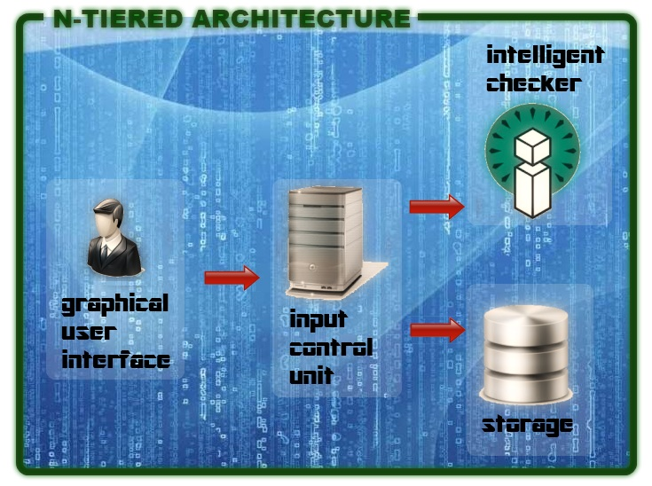
SeamPLE utilizes the N-Tiered Architectural style to power its operations. Starting with the highest level, users interact with various Graphical User Interfaces (GUI) that have been prepared specially for them. This input is sent to the Input Control Unit (ICU) which takes control of this input and decides whether it should be sent to the Intelligent Checker (IC) for validating the input or the storage for running the user inputs and storing or retrieving the appropriate details.

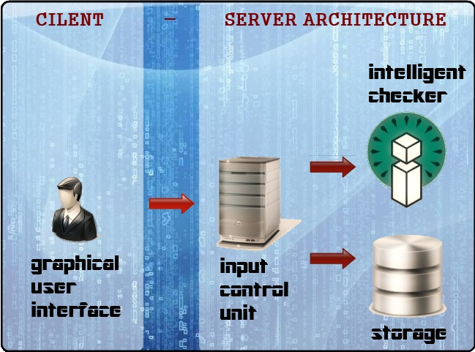
SeamPLE has been cleverly engineered to suit developers’ needs and purposes. By adopting the approach of attaining minimum coupling between the GUI and the ICU, we allow the GUI and other components of the products to be easily exchangeable with other developer created classes. The “Client” Component, as represented by the GUI, can be easily exchanged with other developer created GUI or even the command prompt. The “Server” component, as represented by the rest of our system, can be replaced by developer classes to process any possible user inputs.

Next, we’ll be looking at the overall class diagram of SeamPLE. The class diagram is an essential tool for any prospective developers to continue development or to create new innovations from out system.

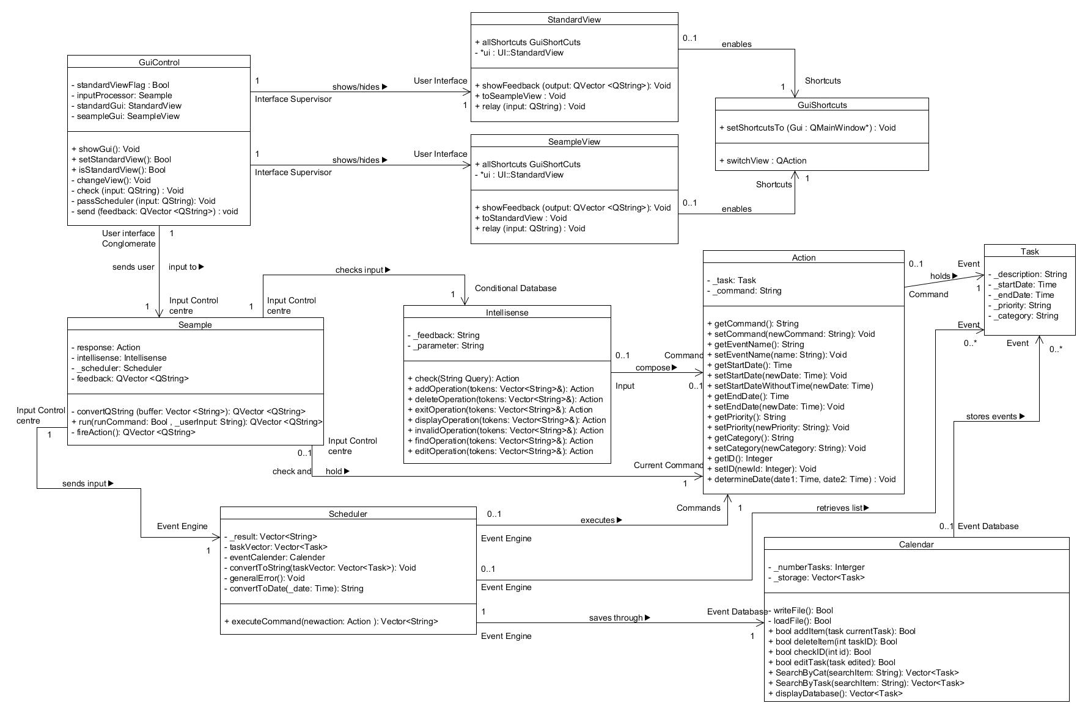
Next, we’ll be looking at the overall class diagram of SeamPLE. The class diagram is an essential tool for any prospective developers to continue development or to create new innovations from out system.

Through the class diagram of SeamPLE, the different relations between the various components are explored. It is important to note that GuiControl must always contain exactly one instance of Seample and Seample must be owned by one instance of GuiControl. This supports the Client – Server architecture that was mentioned earlier on, where one unique client can have only one relation with another unique server.

API Descriptions

Next, we look at possible API descriptions for our program. The API descriptions support what we have implemented in the class diagram above. These descriptions can be used for further implementation (extending on current purposes) and testing (for writing stubs that emulates component behavior)

GUI CONTROL class

send
Description
Function to display feedback to users through the GUI. Call this function when a component wants to interact with the user. API will display all elements accordingly.
Syntax
void send(QVector <QString> feedback)
Input value(s): Qvector of Qstrings containing feedback strings
Return values (s) : None. Output displayed by GUI

passScheduler
Description
Event trigger function when “enter” key is pressed. Function will call scheduler to execute user’s command.
Syntax
void passScheduler(QString input)
Input value(s): Qstrings containing user command input
Return values (s) : None. Output displayed by GUI
check
Description
Calls for intellisense.check to parse user command input.
Syntax
void check(QString input)
Input value(s): Qstrings containing user command input
Return values (s) : None.

INTELLISENSE class
check
Description
Parses user’s command input in the textfield into Action files
Syntax
Action check(string query)
Input value(s): String containing user command input
Return values (s) : None.
getParameter
Description
Determine the input requirements from user command input and generates a feedback string to inform the user of the required fields.
Syntax
string getParameter()
Input value(s): None
Return values (s) : String of colour coded feedback indications

SCHEDULER class
executeCommand
Description
Performs the relevant actions based on the type of operation, input fields.
Syntax
vector<string> executeCommand(Action newaction)
Input value(s): Action class containing input field information
Return values (s) : Vector of string containing feedback messages depending on operation.
Calender
addItem
Description
Stores a user task into the database.
Syntax
bool addItem(task currentTask)
Input value(s): task class containing input field information
Return values (s) : Boolean true if operation is successful false otherwise.
deleteItem
Description
Remove a user task from the database .
Syntax
bool deleteItem(int taskID)
Input value(s): task class containing input field information
Return values (s) : Boolean true if operation is successful false otherwise.

editTask
Description
Edit a user task in the database .
Syntax
bool editTask(task edited)
Input value(s): task class containing input field information
Return values (s) : Boolean true if operation is successful false otherwise.
displayDatabase
Description
Display all user tasks in the database .
Syntax
vector<task> displayDatabase()
Input value(s): None
Return values (s) : Vector containing all task information
CALENDAR class
SearchByTask
Description
Search all user tasks in the database based on task ID.
Syntax
vector<task> SearchByTask(string searchItem)
Input value(s): string containing search field
Return values (s) : Vector containing all task information
SearchByCat
Description
Search all user tasks in the database based on task category.
Syntax
vector<task> SearchByCat(string searchItem)
Input value(s): string containing search field
Return values (s) : Vector containing all task information

SearchByDate
Description
Search all user tasks in the database based on date specified.
Syntax
vector<task> SearchByDate(string searchDate)
Input value(s): string containing search field
Return values (s) : Vector containing all task information.

In the creation of our product, the production team has identified a list of patterns and principles that can be used to enhance the quality of the code as well as to assist in the problem solving. Identical patterns that were observed were applied to the code. These patterns are described below, and the implementation can be replicated for future patches or enhancements to the project.


Singleton Pattern

Certain classes within our program can utilize this pattern as these components (can be global components such as GUI) should carry or control consistent values. Several of the modified classes can also contain methods and objects that can or should be shared across other classes that require these classes.
The issue here is to remove and also to prevent numerous instances of any of the prospective Singleton classes to be created. Before achieving this, we have to identify the prospective Singleton classes:
- GuiControl
  - The Singleton pattern is applied as GuiControl is the control class for all user interfaces programmed into the application. Multiple instances of GuiControl will lead to multiple points of control for the user interfaces. This will lead to logic errors as each instance of GuiControl can contain different values for objects (such as flags) within the class. When displaying to the user interfaces from different instances of GuiControl simultaneously, an illogical sequence of messages may be shown.

- Gui interfaces – StandardView and SeampleView
  - User interfaces used should be similar across the entire application. Multiple instances of each user interface will lead to several interfaces being created at one point of time.

- Seample (control class)
  - The control class is the centre of operations for the entire application. Similar to GuiControl, there shouldn’t be multiple instances of of Seample since objects within Seample will differ across different instances, leading to widely different values being computed as a result.

- Intellisense
  - Intellisense is used to check if the command entered by the user is appropriate for execution. While multiple instances of Intellisense does not lead to drastically different results that affects application performance, it is wise to apply the Singleton pattern as the methods can be shared across different classes that owned Intellisense.

- Scheduler
  - Commands that are entered through user interfaces and authorized by Intellisense are sent into Scheduler for executing. Similar to Intellisense, multiple instances of Scheduler will not affect performance but it is best to apply the Singleton pattern as the methods and objects can be shared across different classes that own Scheduler.
From the above, different problems from classes that can be solved via applying the Singleton pattern are identified. Hence, a common solution affixed to the Singleton pattern can be applied across these affected classes
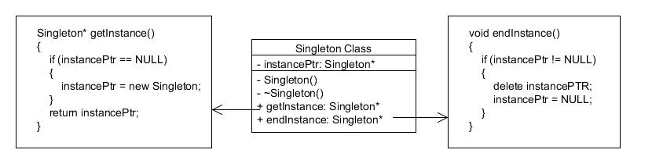

The solution is as seen above. Two methods, getInstance and endInstance, are created for each Singleton class. instancePtr is initially NULL. Hence, when getInstance is called for the first time, the Singleton class is dynamically created and the address is sent to the calling object. Subsequently calls to getInstance will return the same address that instancePtr is pointing to. Similarly, when deleting the dynamically allocated memory through endInstance, it will only occur when instancePtr is not NULL. instancePtr is only assigned the NULL value after it is deleted for the first time, hence subsequent deletes will be nullified.

Note: Alternative solutions include the passing of objects’ addresses across classes that own any of the Singleton classes. However, this solution is inferior as it is harder to handle the dynamically created memory, where issues such as multiple delete leading to deleting at NULL may occur.


Facade Pattern

For certain classes, accessing other classes is important to obtain information that is crucial for their operations. However, it is not advisable for every class in the application to be able to access every other class, even classes that it does not require. It is also better if certain classes operate without knowledge of the intrinsic details of other classes, thus promoting the act of low coupling, which lowers the dependency of components between each other.
Again, we need to identify classes that serve well as the Facade. The two classes identified are:
- GuiControl
  - GuiControl needs to serve as a buffer for the user interfaces. All information sent from the logic components of the application should not access the attributes of the interfaces and display the information directly.
- Seample
  - Similar to GuiControl, all information sent from the user interfaces should not be sent directly to the individual logic components for processing and executing.
Since the similar issue is observed for the two classes identified above, the same solution can definitely be applied to resolve this recurring issue.
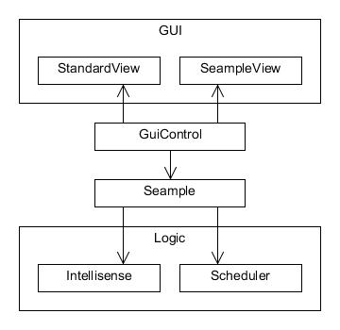
As seen on the left, there is a simplified class diagram on the solution for implementing the Facade pattern. GuiControl and Seample are the facades for each of their own components. While Seample is the control class for the entire program, it can serve as a Facade in this scenario as it prevents the user interface elements from accessing the intrinsic details within the logic component. Similarly, by allowing Seample to access interface elements through GuiControl, GuiControl can also be a Facade class.
Observer Pattern


One pattern that might be applied to our project in the future is the Observer Pattern. The user interfaces implemented for our program might need some response from our calendar class, especially during trigger events such as when certain calendar events expire or are due to expire.
From the issue identified above, the focus now changes to the classes that will subscribe to the observer. For the implementation of this application, the class that should subscribe to the observer should be: GuiControl.
- This is because GuiControl is the control class for the user interfaces. All results should be passed to GuiControl first before being passed down to the individual user interfaces so as to reduce coupling.
As mentioned earlier on, one prospective class that can be “Observed” is: Calendar
- This is to work with what is identified as the observer. The user interfaces might need information on expired events to inform users automatically of events that have expired.
This pattern will be looked into detail for similar occurences within the program. An observer class might be implemented, through the use of slots and signals, to inform the classes as identified above.

While applying patterns to solve recurring problems is essential, crucial principles should be applied to the code so that the quality of the code can be enhanced.

Law of Demeter
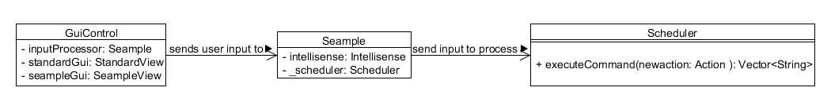
The principle for Law of Demeter is achieved through our code by the use of encapsulation of objects within our different classes. Here, we have an example.

GuiControl contains an instance of Seample, which in turns holds an instance of Scheduler. According to the law, GuiControl is not allowed to access methods of belonging to objects of Seample. The Law of Demeter is not violated as Scheduler is a private object of Seample, hence GuiControl is unable to access its methods.
By conforming to what was observed above and writing code using the above logic, the Law of Demeter is observed.

Single Responsibility Principle
Each class has a single responsibility that it has to uphold (which is also most likely as described by their names, with the exception of Seample). To ensure this, the principle of Separation of Concerns should be observed as far as possible. This is so that concerns can be correctly identified and regrouped into classes, each with their own responsibility. From this concept, the different classes that are pieced up to meet this principle are classes such as the Intellisense. Different functions that are used to determine if a command entered by the user is authorized are created, each with a sole purpose of just performing one task (An example would be the tokenize function whose sole purpose is to separate a sentence to individual words).
The following contains a short write-up on the roles and responsibility of the classes in our application:
GuiControl – Control which user interface is to be displayed and the inputs and outputs to and from the
appropriate interfaces
SeampleView and StandardView – User interfaces that take in input and shows output to users
Seample – Control class that redirects input from user interfaces into logic components and output from
logic components to user interfaces.
Intellisense – Takes in user input and checks if the command inputted is an acceptable command
Scheduler – Execute commands inputted by user

The later you find a bug, the more costly it is to fix

Manual testing is done regularly by each of our members after each implementation. This helps in the sourcing of possible errors and preventing bugs from accumulating and turning into larger errors. Unit testing has also been added by one of our members for the Qt environment that is used for programming the application. While cost may sometimes refer to material costs, it can also refer to the concept of time and effort, where errors left unsolved over time may lead to larger amounts of time and effort required to resolve them.

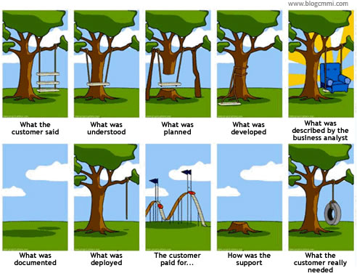
Communication

Communication is very important, and not just from prospective consumers who provide us with much needed valuable feedback, but also from each of our teammates as well. While this principle is essentially not focused on the physical code itself, it requires the programmers to focus on another essential component leading to the code, which is the physical demand and requirement for the code (essentially, why we’re programming in the first place!). In other words, validation and verification are very much affected by this principle. By enforcing strong communication channels between programmers and those not in the programming team, code that fits its demand and with proper implementation can be created. These communication channels, for example, can exist in the form of meetings that are conducted regularly to see if the aims for the code are met.

Appendix (Sequence Diagrams to understand how our program runs)

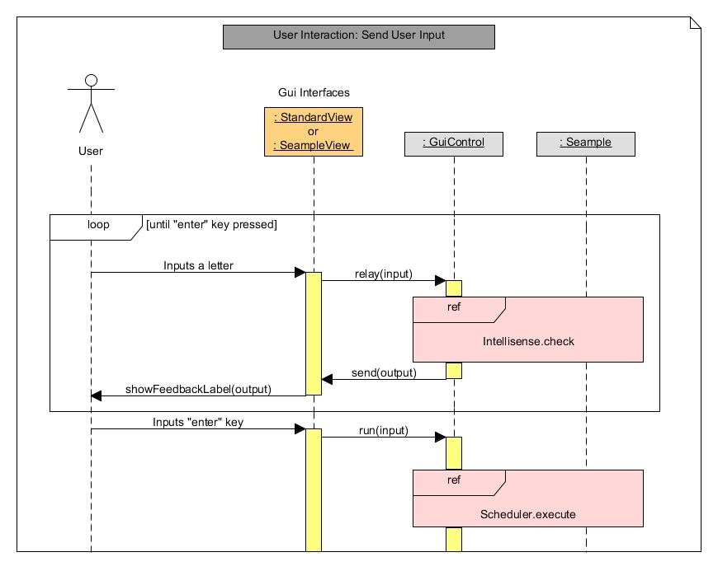

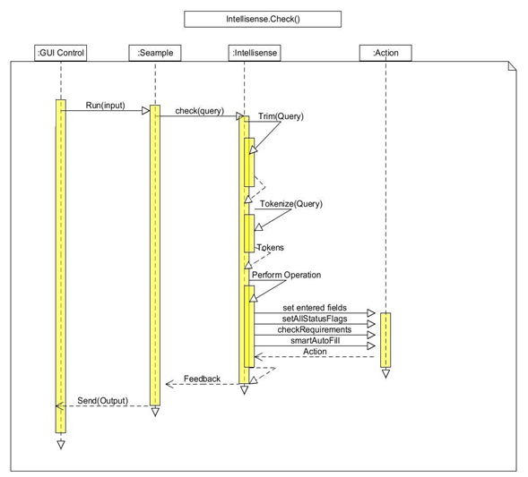

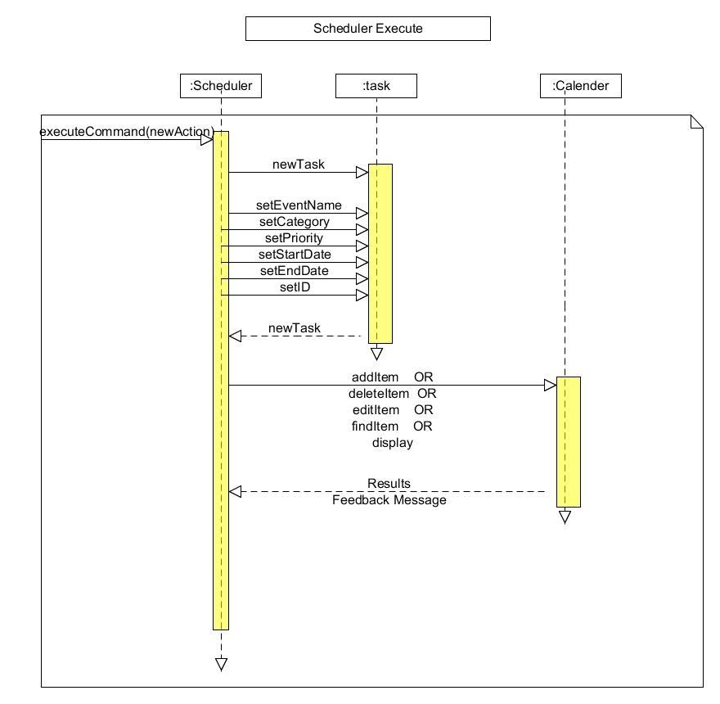

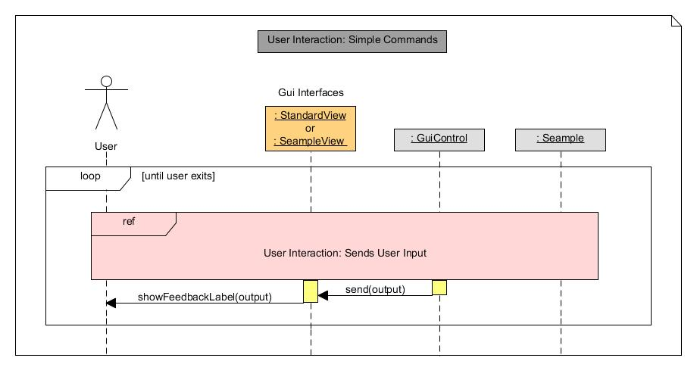
Note: Simple Commands refer to commands such as “add”, “delete” and “edit” where output consist of only one string

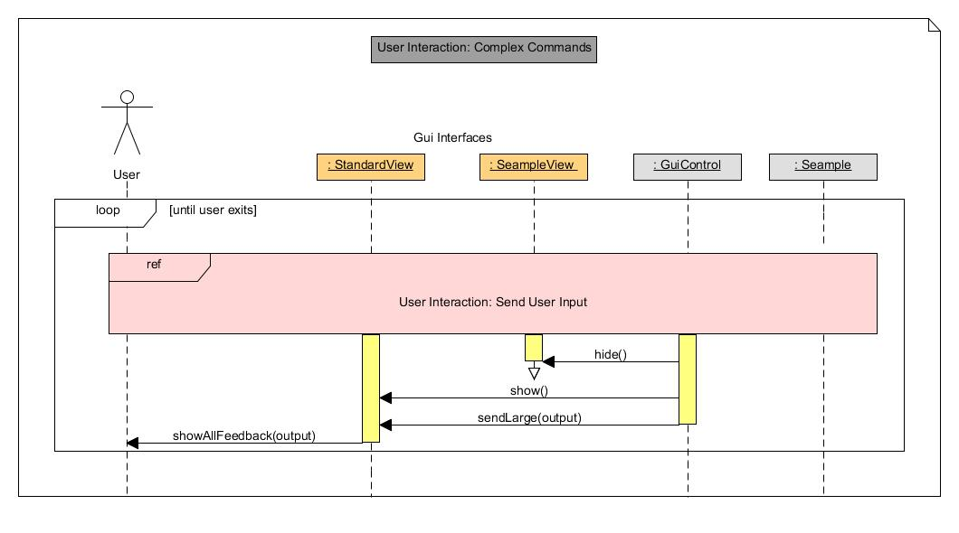
Note: Complex Commands refer to commands such as “find” and “display” where output can consist of more than one string due to multiple results.

